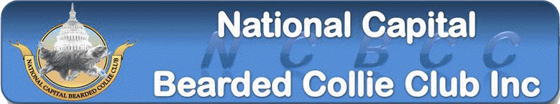
BCCA Herding Instinct Certified (HIC) Test
Saturday June 10th, 2017
Scarlets Mill,
2384 Hay Creek Road,
Birdsboro, PA
As part of our herding event, the NCBCC is offering an instinct test on Saturday June 10th. Your dog must be at least 6 months old and it is recommended (though it is not required) that your dog have some exposure to sheep prior to the test.
The instinct test is conducted under the AKC program. A passing dog can receive both of the following:
- One leg of the two legs required for the AKC Herding Instinct Certificate (HIC). You have to earn a second leg under a different judge at another trial for the certificate.
- The one leg required for the BCCA Herding Instinct Certificate (HIC)

If you want both, then complete
- The AKC premium (to be mailed separately) and return it to the trial secretary listed in the premium AND the $50 fee.
- The BCCA HIC entry form (page 2) and return with a copy of the dog’s AKC registration paper to the address listed.

If you have multiple dogs you need to fill out a separate form for each dog.
We cannot accept day of entries so please be sure to enter prior to the closing date. There are only 10 spaces available for the instinct test so enter early!!
Please see trial premium for detailed information on directions, hotels, etc.
For more information on BCCA Herding Instinct testing refer to the web page:
http://www.beardedcollieclub.us/wp-content/uploads/herding/HIC_Slide_Presentation_August_2012.pdf
Registration Form for BCCA Herding Instinct Certificate
Please write legibly to insure that you certificate is correctly done. Deadline 5/27/2017
This dog is also entered in the AKC instinct test on the separate premium: ____Yes _____No
Registered Name: ______________________________________________________________________
Call Name:_________________________________ Date of Birth:_____________ Sex(circle): M F
Sire Name:____________________________________________________________________________
Dam Name:___________________________________________________________________________
Breeder’s Name:_______________________________________________________________________
Owner Name:__________________________________________________________________________
Owner Address:________________________________________________________________________
________________________________________________________________________
Owner Phone (in case spelling needs to be confirmed):________________________________________
Send completed form and copy of AKC registration paper to: NCBCC BCCA HIC Test
7009 Birkenhead Place, Apt-E
Alexandria, VA 22315

Note: Certificates will be sent by the BCCA approximately 4 to 6 weeks after the test. If you have not received yours by then contact David Fruehwald at (dfruehwald@yahoo.com)

